Lab 01 – Worksheet

Name:Faaz Shahab, Mohib Ul Mehdi | ID:fs09911,mm09730 | Section:T2

Note: Assumptions and logics should be explained separately in tasks after the task results.

Task 3.

Provide appropriately commented codes (Mention question part before each part)
li x1,5 #a=5
addi x2,x0,0 #b=0+0
addi x1,x2,32 #a=b+32
add x4,x1,x2 #temp1=a+b
addi x6,x4,-5 #d=temp1 - 5
sub x4,x1,x6 #temp1=a-d
sub x3,x2,x1 # temp2=b-a
add x5,x4,x3 #temp3=temp1+temp2
add x7,x5,x6 #e=temp3+d
add x7,x7,x1
add x7,x7,x2
add x7,x7,x6

end:
j end

Add screenshot of your results (register)
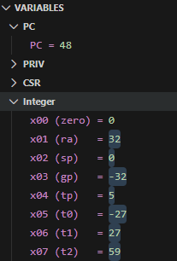

Task 4a
Write the RISC-V assembly code for each item below. Try guessing the result in each destination before executing the instruction and corroborate it after execution:

- Store x10 as unsigned integer at address 0x100.
li x10,0x78786464
sw x10, 0x100(x0)

end:
j end

- Store x11 as unsigned integer at address 0x1F0.
li x11,0xA8A81919
sw x11, 0x1F0(x0)

end:
j end

- Load an unsigned short integer (two bytes) from address 0x100 in x12.
lhu x12, 0x100(x0)

- Load a short integer from address 0x1F0 in register x13.
lh x13, 0x1F0(x0)

- Load a singed character from address 0x1F0 in register x14.
lb x14, 0x1F0(x0)

Add screenshots of your results (register & memory both)
Registers:
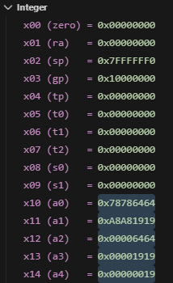

Memory:

Task 4b

Provide appropriately commented codes (Mention question part before each part)
#Base addresses
li x10, 0x100 #a(char array)
li x11, 0x200 #b(short array)
li x12, 0x300 #c(unsigned integer array)

#adding dummy values to each array to show wroking
# char array a = [1,2,3,4]
li x5,1
sb x5,0(x10)
li x5,2
sb x5,1(x10)
li x5,3
sb x5,2(x10)
li x5,4
sb x5,3(x10)

# short array b = [10,20,30,40]
li x5,10
sh x5,0(x11)
li x5,20
sh x5,2(x11)
li x5,30
sh x5,4(x11)
li x5,40
sh x5,6(x11)
# unsigned int array c = [0,0,0,0]
sw x0,0(x12)
sw x0,4(x12)
sw x0,8(x12)
sw x0,12(x12)

#i=0
lb x13, 0(x10) #a[0]
lh x14, 0(x11) #b[0]
add x15, x13, x14 #a[0]+b[0]
sw x15, 0(x12) #c[0]

#i=1
lb x13, 1(x10) # a[1]
lh x14, 2(x11) # b[1]
add x15, x13, x14
sw x15, 4(x12) # c[1]

#i=2
lb x13, 2(x10) #a[2]
lh x14, 4(x11) #b[2]
add x15, x13, x14
sw x15, 8(x12) #c[2]

#i=3
lb x13, 3(x10) #a[3]
lh x14, 6(x11) #b[3]
add x15, x13, x14
sw x15, 12(x12) #c[3]

end:
j end

Add screenshots of your results (register & memory both)
Char array a:

Short array b:

Unsigned int array:
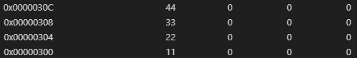

Registers:
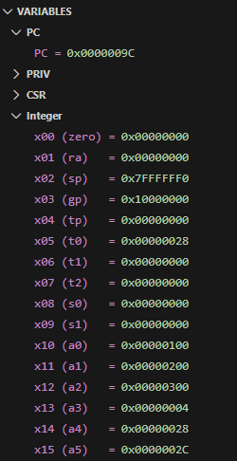

Lab 01

Assessment Rubrics

Task No. | LR 2  Code | LR 5  Results | AR 7  Report Submission/Code Comments
Task 1a | /05 | /05 | /20
Task 1b | /10 | /05 | /20
Task 2a | /10 | /05 | /20
Task 2b | /20 | /05 | /20
Exercise | /10 | /05
Total Points |  | /100 Points
CLO Mapped |  | CLO 2

# | Assessment Elements | Level 1: Unsatisfactory | Level 2: Developing | Level 3: Good | Level 4: Exemplary
LR2 | Program/Co de/ Simulation Model/ Network Model | Program/code/simulation model/network model does not implement the required functionality and has several errors. The student is not able to utilize even the basic tools of the software. | Program/code/simulation model/network model has some errors and does not produce completely accurate results. Student has limited command on the basic tools of the software. | Program/code/simulation model/network model gives correct output but not efficiently implemented or implemented by computationally complex routine. | Program/code/simulation  /network model is efficiently implemented and gives correct output. Student has full command on the basic tools of the software.
LR5 | Results & Plots | Figures/ graphs / tables are not developed or are poorly constructed with erroneous results. Titles, captions, units are not mentioned.  Data is presented in an obscure manner. | Figures, graphs and tables are drawn but contain errors. Titles, captions, units are not accurate. Data presentation is not too clear. | All figures, graphs, tables are correctly drawn but contain minor errors or some of the details are missing. | Figures / graphs / tables are correctly drawn and appropriate titles/captions and proper units are mentioned. Data presentation is systematic.
AR9 | Report Content/Code Comments | No summary provided. The number/amount of tasks completed below the level of satisfaction and/or submitted late | Couldn’t provide good summary of in-lab tasks. Some major tasks were completed but not explained well.  Submission on time. Some major plots and figures provided | Good summary of In-lab tasks. All major tasks completed except few minor ones. The work is supported by some decent explanations, Submission on time, All necessary plots, and figures provided | Outstanding Summary of In-Lab tasks. All task completed and explained well, submitted on time, good presentation of plots and figure with proper label, titles and captions

